**CHAPTER-1**

**INTRODUCTION**

Online voting systems are software platforms used to securely conduct

votes and elections. As a digital platform, they eliminate the need to cast your

votes using paper or having to gather in person. They also protect the integrity

of your vote by preventing voters from being able to vote multiple times.

Many secure voting platform vendors provide supportive vote management

consulting services that help organizations design and implement their voting

procedures. These services help organizations save time, stick to best practices,

and meet internal requirements and/or external regulations, such as third-party

vote administration needs.

Voting schemes have evolved from counting hands in early days to

systems that include paper, punch card, mechanical lever and optical-scan

machines. Electronic voting systems provide some characteristic different from

the traditional voting technique, and also it provides improved features of voting

system over traditional voting system such as accuracy, convenience, flexibility,

privacy, verifiability and mobility. But it suffers from various drawbacks such

as Time consuming, Consumes large volume of pare work, No direct role for

the higher officials, Damage of machines due to lack of attention, Mass update

doesn’t allows users to update and edit many item simultaneously. These

drawbacks are overcome by Online Voting System. Online Voting System is a

system by which any Voter can use his/her voting rights from anywhere in the

country. We provide a detailed description of the functional and performance

characteristics of online voting system.Voter can cast their votes from anywhere

in the country without visiting to voting booths, in highly secured way.

1. **ABSTRACT**:

The main objective of the democracy is “vote” by which the people can

elect the candidates for forming an efficient government to satisfy their needs

and requests such that their standard living can be improved. In developing

countries like “INDIA” the election commission follows manual voting

mechanism which is done by electronic voting machine. This machine is placed

in the poll booth centre and is monitored by higher officials. due to some illegal

activities the polling centre are misused and people's vote to right has been

denied. This seldom occurs in rural areas as well as in urban cities because the

educated people are not interested in casting their votes to candidates who

represent their respective areas. To ensure 100% voting automation came into

play.

It also creates and manages voting and an election detail as all the users

must login by user name and password and click on his favourable candidates to

register vote. The persons who are above 18years are extracted from

Aadhar card database since it had become mandatory in present scenario.

Automatically a new voter id with necessary details will be created and an

intimation will be given to the persons through their e-mail. This will increase

the voting percentage in India. By applying high security it will reduce false

votes. We provide a detailed description of the functional and performance

characteristics of online voting system. Voter can cast their votes from

anywhere in the country without visiting to voting booths, in highly secured

way.

**1.1 PROBLEM DEFINITION:**

The proposed system is mainly designed for our country. It has three

phases. First the details of the persons who are above 18years are extracted from

Aadhar card database since it had become mandatory in present scenario.

Automatically a new voter id with necessary details will be created and an

intimation will be given to the persons through their e-mail. At the time of voting,

the user can specify their id and password. To ensure more security, finger prints

of the voter is used as the main authentication resource. Since the finger pattern

of each human being is different, the voter can be easily authenticated. The

system Allow the voter to vote through his fingerprint. Finger print is used to

uniquely identify the user. The finger print minutiae features are different for each

human being. Finger print is used as a authentication of the voters. Users are

individuals who interact with the system. All user interaction is performed

remotely through the user’s web browser when the system is web based.

**1.2 PURPOSE, AIMS AND OBJECTIVES**

The main aim of this project work is to design online voting software which

among others be able to achieve the following targets;

* Each voter will be able to vote only once
* Nobody will have access to the votes before the official opening of the electronic ballot box.
* The votes cast cannot be intercepted, modified or diverted
* The on-line site will resist any attack
* Only registered voters will have access to the application
* Voters will be protected against any attempt of identified theft.
* The secrecy of the vote will be guaranteed
* Rigging of the election will be controlled
* The system will not accept vote outside the voting period
* It shall put to an end the indiscriminate alteration of election result by
* officer of the electoral committees in SUG elections.

**1.3 SECURITY REQUIREMENTS OF ONLINE VOTING SYSTEM:**

1. Eligibility: only the legitimate person should be able to vote.

2. Authenticity: only the authorized person should be able to vote.

3. Uniqueness: No voter should be able to vote twice.

4. Accuracy: Recording of votes should be done correctly.

5. Integrity: Number of casted votes should not be altered.

6. Fairness: Incomplete tabulation of results should not be done.

7. Reliability: Systems must work robustly with greater assurance by minimizing the errors.

8. Confidentiality: Data should not be leaked.

**1.4 EXISTING SYSTEM:**

The Existing System of Election is running manually. The Voter

has to Visit to Booths to Vote a Candidate so there is wastage of Time.

The Voter has to manually register into the Voter List. Also Vote

counting has to be done manually. All the Information of the Voter or

Candidate is to be filling in manually. Voter must be present in his/her

Constituency to give his/her Vote. There are Electronic Voting Machines

used which Takes More Cost. The voting system previously being used

by the Government is a paper based system, in which the voter simply

picks up ballots sheets from electoral officials, tick off who they would

like to vote for, and then cast their votes by merely handing over the

ballot sheet back to electoral official.

Existing System consist of methods like paper based voting, Lever

voting machine, Punch card and Optical voting machine. The main

problem with existing system was time consuming which used to take lot

of time for voting. Paper based voting method were used in existing

system which also gave the results of fake voting.

**1.5 PROPOSED SYSTEM:**

To overcome the above stated problems a new system is proposed which

is time saving and provides more security. The proposed system is mainly

designed for our country. It has three phases. First the details of the persons who

above 18years are extracted from Aadhar card database since it had become

mandatory in present scenario. Automatically a new voter id with necessary

details will be created and an intimation will be given to the persons through

their e-mail. At the time of voting, the user can specify their id and password.

To ensure more security, finger prints of the voter is used as the main

authentication resource. Since the finger pattern of each human being is

different, the voter can be easily authenticated. The system Allow the voter to

vote through his fingerprint. Finger print is used to uniquely identify the user.

The finger print minutiae features are different for each human being. Finger

print is used as a authentication of the voters.

Advantages of using this application is time saving and voting percentage

can be increased and high security can be implied for preventing false voting.

This application contains two level of user’s administrator level and voter level

where each level has different functionality. Election commission of India will

update voter’s details to database regularly.

**Fingerprint Recognition**: Fingerprint recognition describes the process

of obtaining a digital representation of a fingerprint and comparing it to a stored

digital version of a fingerprint. Electronic fingerprint scanners capture digital

"pictures" of fingerprints, either based on light reflections of the finger's ridges

and valleys, ultra sonics, or the electrical properties of the finger's ridges and

valleys. These pictures are then processed into digital templates that contain the

unique extracted features of a finger. These digital fingerprint templates can be

stored in databases and used in place of traditional passwords for secure access.

Instead of typing a password, users place a finger on an electronic scanner. The

scanner, or reader, compares the subsist fingerprint to the fingerprint template

stored in a database to resolve the identity and validity of the person requesting

access.

**CHAPTER – 2**

**2. LITERATURE REVIEW**

In India, voting is been done only in booths arranged by the Election

Commission. Computer scientists who have done work in, or are interested in,

electronic voting all seem to agree on two things:

* Internet voting does not meet the requirements for public elections
* Currently widely-deployed voting systems need improvement

Most people believe that the current system should be changed; there is

much disagreement on how such changes should be made. The main thesis of

this project is to develop online voting system with thumb verification, for

finger print accessing and eyeball recognition we use AADHAR card database.

At the time of voting in the elections, the e-voting process authentication can be

done using finger vein sensing, which enables the electronic ballot reset for

allowing voters to cast their votes. Also the voted data and voters details can be

sent to the nearby Database Administration unit in a timely manner.

A worthy e-voting system must perform most of these tasks while

complying with a set of standards established by regulatory bodies, and must

also be capable to deal successfully with strong requirements associated

with security, accuracy, integrity,

swiftness, privacy, audibility, accessibility, cost-

effectiveness, scalability and ecological sustainability.

Electronic voting technology can include punched cards, optical scan voting

system and specialized voting kiosks (including self-contained direct recording

electronic voting system, or DRE). It can also involve transmission of  and

votes via ballots telephones, private computer networks, or the Internet.

An online voting system for Indian election is proposed for the first time

in this paper. The proposed model has a greater security in the sense that voter

high security password is confirmed before the vote is accepted in the main

database of Election Commission of India. The additional feature of the model

is that the voter can confirm if his/her vote has gone to correct candidate/party.

In this model a person can also vote from outside of his/her allotted

constituency or from his/her preferred location. In the proposed system the

tallying of the votes will be done automatically, thus saving a huge time and

enabling Election Commissioner of India to announce the result within a very

short period.

In India, currently there are two types of voting system in practice. They

are secret Ballet paper and Electronic Voting Machines (EVM), but both of the

process have some limitation or demerits. In India online voting has not been

yet implemented. The current voting system is not safe and secure too. The

voters need to go to distributed places like polling booths and stand in a long

queue to cast their vote, because of these reasons most of the people misses

their chance of voting. The voter who is not eligible can also cast its vote by

fake means which may leads to many problems. That's why in this project we

have to propose a system or way for voting which is very effective or useful in

voting. In our approach we have three level of security in voting process. The

first level is the verification of unique id number (UID), second level is the

verification of election id number (EID) and third level is face recognition or

face matching. The security level of our system is greatly improved by the new

application method for each voter. The user authentication process of the system

is improved by adding face recognition in an application which will identify

whether the particular user is authenticated user or not.

**CHAPTER 3**

**SYSTEM ANALYSIS**

System analysis is a problem solving technique that decomposes a system into component pieces of purpose of studying how well those component parts work and interact to accomplish their purpose the following chapter provides the detail description of the existing system. It also provides an overview of the proposed system and feasibility of the smart voting system.

**3.1 EXISTING SYSTEM**

The Existing System of Election is running manually. The Voter has to Visit to Booths to Vote a Candidate so there is wastage of Time. The Voter has to manually register into the Voter List. Also Vote counting has to be done manually. All the Information of the Voter or Candidate is to be filling in manually. Voter must be present in his/her Constituency to give his/her Vote. There are Electronic Voting Machines used which Takes More Cost.

**3.1.1 Voting System**

This system is mainly designed for our country. It has three

phases. First the details of the persons who are above 18years are extracted from

Aadhar card database since it had become mandatory in present scenario.

Automatically a new voter id with necessary details will be created and an

intimation will be given to the persons through their e-mail. At the time of voting,

the user can specify their id and password. All user interaction is performed

remotely through the user’s web browser when the system is web based.

**3.2 Drawbacks**

* + 1. **Smart Voting**
* Vulnerability to hacking.
* Voter verified paper audit trails.
* Susceptibility to fraud.
* Accuracy to capturing voter’s intent

**3.3 PROPOSED SYSTEM**

To overcome the above stated problems a new system is proposed which

is time saving and provides more security. The proposed system is mainly

designed for our country. It has three phases. First the details of the

persons who are above 18years are extracted from Aadhar card database

since it had become mandatory in present scenario. Automatically a new

voter id with necessary details will be created and an intimation will be

given to the persons through their e-mail. At the time of voting, the user

can specify their id and password. To ensure more security, finger prints

of the voter is used as the main authentication resource. Since the finger

pattern of each human being is different, the voter can be easily

authenticated. The system Allow the voter to vote through his fingerprint.

Finger print is used to uniquely identify the user. The finger print

minutiae features are different for each human being. Finger print is used

as a authentication of the voters.

**3.4 FEASIBILITY STUDY**

An analysis and evaluation of a proposed project to determine if it is technically feasible, is feasible within the estimated cost, and will be profitable. Feasibility studies are almost always conducted where large sums are at stake. A feasibility study aims to objectively and rationally uncover the strengths and weaknesses of an existing Voting system applications and threats present in the environment, the resources required to carry through, and ultimately the prospects for success in the voting system.

**3.4.1 Tests of Feasibility**

Feasibility study is conducted once the problem clearly understood. Feasibility study is necessary to determine that the proposed system in voting is feasible by considering the technical, operational, and economical factors. By having a detailed feasibility study the management in the will have a clear-cut view of the proposed system of the Voting system. Feasibility study encompasses the following things:

* Technical Feasibility
* Economical Feasibility
* Operational feasibility

**3.4.1.1 Technical Feasibility**

A large part of determining resources has to do with assessing technical feasibility. It considers the technical requirements of the proposed project of smart voting system. The technical requirements are then compared to the technical capability of the voting system. The systems project is considered technically feasible if the internal technical capability is sufficient to support the voting system’s requirements. The analyst must find out whether current technical resources can be upgraded or added to in a manner that fulfils the request under consideration.

The essential questions that help in testing the operational feasibility of a system include the following:

* Is the project feasible within the limits of current technology?
* Is it available within given resource constraints?
* Is it a practical proposition?
* Manpower- programmers, testers & debuggers
* Are the current technical resources sufficient for the new system?
* Can they be upgraded to provide to provide the level of technology necessary for the new system?

**3.4.1.2 Operational Feasibility**

Operational feasibility is dependent on human resources available for the project and involves projecting whether the system will be used if it is developed and implemented. Operational feasibility is a measure of how well a proposed system in voting solves the problems, and takes advantage of the opportunities identified during scope definition and how it satisfies the requirements identified in the requirements analysis phase of voting systems.

The essential questions that help in testing the operational feasibility of a system include the following:

* Does current mode of operation provide adequate throughput and response time?
* Does current mode provide end users and managers with timely, pertinent, accurate and useful formatted information?
* Does current mode of operation provide cost-effective information services to the business?
* Could there be a reduction in cost and or an increase in benefits?

**3.4.1.3 Economical Feasibility**

Economic analysis could also be referred to as cost/benefit analysis. It is the most frequently used method for evaluating the effectiveness of a new system of the voting system. In economic analysis the procedure is to determine the benefits and savings that are expected from a candidate system and compare them with costs.

If benefits outweigh costs, then the decision is made to design and implement the voting system. An entrepreneur must accurately weigh the cost versus benefits before taking an action.

Possible questions raised in economic analysis are:

* Is the system cost effective?
* Do benefits outweigh costs and system study?

**CHAPTER 4**

**SYSTEM SPECIFICATION**

**4.1 FUNCTIONAL REQUIREMENTS:**

**4.1. 1 Voting:**

a. The system should allow users to vote through online.

b. The system shall inform the user’s voter id and aadhar id is wrong.

c. The system shall inform the user about spelling mistakes.

d. The system shall inform the user about the candidate in that particular area.

**4.1.2 Verification:**

a. The system should allow users to verify for information about voter id and aadhar id details.

b. The system should allow users to search for information about candidates.

**4.1.3 Feedback:**

a. The user should be able to leave feedback, which is comprised of a text message and a rating.

**4.1.4 Administrative system**

a. Information management: The administrator should be able to add, update and delete informations.

b. Feedback management: The administrator should be able to view and delete feedbacks.

**4.2 NON-FUNCTIONAL REQUIREMENTS**

**4.2.1 User Interface:**

a. The system shall maintain an easy to use interface across all functionality and for all users

b`. The client’s user interface should be compatible with all commonly used browsers, such as Internet explorer, Firefox, Google chrome and Safari.

**4.2.2 Scalability:**

a. The system shall be able to scale based on the number of users accounts using the system.

**4.2.3 Security:**

a. The administrative system should be protected from unauthorized access.

b. The database should protected from attacks and unauthorized access.

c. The interface should be protected from attacks.

d. All passwords should be stored as a secure hash of the administrator password.

**4.2.4 Portability:**

a. The system should run on a variety of operating systems that support the Java language.

b. The system should run on a variety of hardware.

**4.2.5 Maintainability:**

a. The system should be easy to maintain.

b. There should be a clear separation between the interface and the business logic code.

c. There should be a clear separation between the data access objects that map the database and the business logic code.

**4.2.6 Exception handling:**

a. Exceptions should be reported effectively to the user if they occur.

**4.2.7 Ethics:**

a. The system shall not store or process any information about its users.

**4.3 HARDWARE REQUIREMENTS**

Processor : Dual core processor

RAM : 4 GB

Hard Disk : 250 GB

Monitor : 16’’ Color Monitor

Keyboard : Standard 110 keys

Pointing Device : Mouse

Smart Phone : Any type

**4.4 SOFTWARE REQUIREMENTS**

Programming Language : PHP, JAVASCRIPT

Operating System : Windows/Ubuntu/Linux/Mac

Front End : HTML

Back End : My sql

Web Browser : Mozilla Firefox, Google Chrome

**CHAPTER 5**

**SOFTWARE DESCRIPTION**

A software requirements specification (SRS) is a description of a [software system](https://en.wikipedia.org/wiki/Software_system) to be developed. It lays out [functional](https://en.wikipedia.org/wiki/Functional_requirement) and [non-functional requirements](https://en.wikipedia.org/wiki/Non-functional_requirements), and may include a set of [use cases](https://en.wikipedia.org/wiki/Use_case) that describe user interactions that the software must provide. Software requirements specification establishes the basis for an agreement between users and banking bot on what the software product is to do as well as what it is not expected to do. Software requirements specification permits a rigorous assessment of requirements before design can begin and reduces later redesign. It should also provide a realistic basis for estimating product costs, risks, and schedules.

**5.1 FRONT END**

The front end is designed using UI design. Java framework which includes a collaborative platform for bot creating, hosting and deploying.Java is the collaborative end to end bot platform made by developers for the developers. Here all the tools are integrated and it allows automatic detection of entities. API Connectivity is been done using PHP.

**5.1.1 JAVASCRIPT**

Java script is a programming language and a platform. It is a High level robust, Object oriented and secure Programming language.

Any hardware and software environment in which a program runs, is known as a platform. Java runtime environment and API are the platforms. It is widely used by the world.

**5.1.1.1 Features**

* Simple: Java script is very easy to learn, and its syntax is simple, clean and easy to understand. According to Sun, Java language is a simple programming
* Object Oriented: Java script is an Object-Oriented programming language. Everything in Java is an object. Object-oriented means we organize our software as a combination of different types of objects that incorporates both data and behavior.
* Faster: It is faster than other Programming language
* Open Source: Open source means you no need to pay for use Java script, you can free download and use.
* Platform Independent: Java script is platform independent because it is different from other languages like [C](https://www.javatpoint.com/c-programming-language-tutorial), [C++](https://www.javatpoint.com/cpp-tutorial), etc. which are compiled into platform specific machines while Java is a write once, run anywhere language.
* Portable: It is portable because it facilitates you to carry the bytecode to any platform. It doesn't require any implementation.

**5.1.1.2 Advantages**

* It is easy to learn. It was designed to be easy to use and is therefore easy to write, compile, debug, and learn than other programming language.
* Java script is object-oriented.  
  This allows you to create modular programs and reusable code.
* Java script is platform-independent.  
  One of the most significant advantages of Java is its ability to move easily from one computer system to another. The ability to run the same program on many different systems is crucial to World Wide Web software, and Java succeeds at this by being platform-independent at both the source and binary levels.
* Java script is distributed.  
  Java is designed to make distributed computing easy with the networking capability that is inherently integrated into it. Writing network programs in Java is like sending and receiving data to and from a file.
* Java script is secure.  
  Java considers security as part of its design. The Java language, compiler, interpreter, and runtime environment were each developed with security in mind.
* Java a fully object-oriented language and its platform independence and speed on Linux server helps to build large and complex web applications.
* So, in general Java is cheap, secure, fast and reliable for developing web applications.

**5.1.2 Web**

The Web is the common name for the World Wide Web, a subset

of the Internet consisting of the pages that can be accessed by

a Web browser. Many people assume that the Web is the same as the

Internet, and use these terms interchangeably.

* + - 1. **Features**
* Easy to read. If background colours or images are

used, the text on top of the background should be in a

colour that can easily be seen.

* Easy to navigate. A visitor should be able to find the

information they are looking for without hassle and

frustration. The site's navigation buttons should be

grouped together.

* Comfortably viewed. A Web site should be easily

viewable in all screen sizes without a visitor having to

scroll horizontally (left to right).

**5.1.2.2 Advantages**

|  |
| --- |
|  |

* Zero install
* Reduce business costs
* Centralised data
* Quick and easy updates
* Always up-to-date
* Direct Access

**5.1.3 PHP**

PHP is a powerful server-side scripting language for creating dynamic and interactive websites.

PHP is the widely-used, free, and efficient alternative to competitors such as Microsoft's ASP. PHP is perfectly suited for Web development and can be embedded directly into the HTML code.

The PHP syntax is very similar to Perl and C. PHP is often used together with Apache on various operating systems. It also supports ISAPI and can be used with Microsoft's IIS on Windows.

**5.1.3.1 Features**

* Simple. It is very simple and easy to use, compare to other scripting language it is very simple and easy, this is widely used all over the world.
* Interpreted. It is an interpreted language, i.e. there is no need for compilation.
* Faster. It is faster than other scripting language e.g. asp and jsp.
* Open Source. Open source means you no need to pay for use php, you can free download and use.

**5.1.3.2 Advantages**

* + Open source
  + Cross-platform
  + Support
  + High returns
  + Huge community
  + Embedding
    1. **HTML**

HTML, which stands for Hypertext Mark-up Language, is the primary [mark-up language](https://www.lifewire.com/what-are-markup-languages-3468655) used to structure content on the [web](https://www.lifewire.com/difference-between-the-internet-and-the-web-2483335). Every single web page on the internet has at least some HTML mark-up included in its source code, and most websites are comprised of many [HTML or HTM files](https://www.lifewire.com/htm-html-file-2621691).

The language rules that HTML follows describe to a [web browser](https://www.lifewire.com/what-is-a-browser-446234) how to display the text that makes up the web page. Without HTML to structure the content on the page, the text would appear formless, without the colour, tables, formatting, lists, and headings that make it easier to read.

**5.1.4.1 Features**

* Platform independent language.
* It is not case sensitive language.
* Title, Lists, Paragraph, etc.
* Controls fonts, colours, positioning
* We can build tables.

**5.1.4.2 Advantages**

* HTML is easy enough to write.
* HTML is that it is easy to code.
* HTML also allows the use of templates, which makes designing a webpage easy.
* Very useful for beginners in web designing field.

**5.1.5 CSS**

* CSS stands for Cascading Style Sheets
* CSS describes how HTML elements are to be displayed on screen, paper, or in other media
* CSS saves a lot of work. It can control the layout of multiple web pages all at once
* External stylesheets are stored in CSS files

**5.1.5.1 Features**

1. CSS Animations and Transitions.
2. Calculating Values With calc ().
3. Advanced Selectors.
4. Generated Content and Counters.
5. Gradients.
6. Webfonts.
7. Box Sizing.
8. Border Images.
9. Media Queries.
10. Multiple Backgrounds.

**5.1.5.2 Advantages**

* Making changes to the layout. CSS makes it very easy to change the style of a document. ...
* Consistency. Layout and position of navigation can be completely consistent across a site. This was previously possible only using frames.
* Easier to maintain and update.
* Greater consistency in design.
* More formatting options.
* Lightweight code.
* Faster download times.

|  |
| --- |
|  |
|  |
|  |
|  |
|  |
|  |
|  |

**5.2 BACK END**

The back end is designed using MySQL, whose primary function is to store data securely and retrieve it later, as requested by other software applications.

**5.2.1 MySQL**

MySQL is an open-source relational database management system (RDBMS).The MySQL development project has made its source code available under the terms of the GNU General Public License, as well as under a variety of proprietary agreements. MySQL was owned and sponsored by a single for-profit firm, the Swedish company MySQL AB, now owned by Oracle Corporation. For proprietary use, several paid editions are available, and offer additional functionality.

MySQL is a central component of the LAMP open-source web application software stack (and other "AMP" stacks). LAMP is an acronym for "Linux, Apache, MySQL, Perl/PHP/Python". Applications that use the MySQL database include: TYPO3, MODx, Joomla, WordPress, Simple Machines Forum, phpBB, MyBB, and Drupal.

**5.2.2 Features of MySQL**

* A broad subset of ANSI SQL 99, as well as extensions.
* Cross-platform support.
* Stored procedures, using a procedural language that closely adheres to SQL/PSM.
* Triggers.
* Cursors.
* Updatable views.
* Online DDL when using the InnoDB Storage Engine.
* Information schema.

**5.2.3 Advantages of MySQL**

* Data Security
* On-Demand Scalability
* High Performance
* Round-the-Clock Uptime
* Comprehensive Transactional Support
* Complete Workflow Control
* Reduced Total Cost of Ownership
* The Flexibility of Open Source

**CHAPTER 6**

**PROJECT DESCRIPTION**

Online voting systems are software platforms used to securely

conduct votes and elections. As a digital platform, they eliminate the need

to cast your votes using paper or having to gather in person. They also

protect the integrity of your vote by preventing voters from being able to

vote multiple times.Many secure voting platform vendors provide

supportive vote management consulting services that help organizations

design and implement their voting procedures. These services help

save time, stick to best practices, and meet internal requirements and/or

external regulations, such as third-party vote administration needs.

**6.1 PROBLEM DEFINITION:**

The proposed system is mainly designed for our country. It has three

phases. First the details of the persons who are above 18years are extracted from

Aadhar card database since it had become mandatory in present scenario.

Automatically a new voter id with necessary details will be created and an

intimation will be given to the persons through their e-mail. At the time of voting,

the user can specify their id and password. To ensure more security, finger prints

of the voter is used as the main authentication resource. Since the finger pattern

of each human being is different, the voter can be easily authenticated. The

system Allow the voter to vote through his fingerprint. Finger print is used to

uniquely identify the user. The finger print minutiae features are different for each

human being. Finger print is used as a authentication of the voters. Users are

individuals who interact with the system. All user interaction is performed

remotely through the user’s web browser when the system is web based.

**6.2 OVERVIEW OF THE PROJECT**

The voting system provides a complete set of methods in order to perform the voting operations. All users of the voting system need the same functionality to complete their varied tasks.

The voting system allows you to:

* Each voter will be able to vote only once
* Nobody will have access to the votes before the official opening of the electronic ballot box.
* The votes cast cannot be intercepted, modified or diverted
* The on-line site will resist any attack
* Only registered voters will have access to the application
* Voters will be protected against any attempt of identified theft.

**6.3 MODULE DESCRIPTION**

**6.3.1 Voting**

* The system should allow users to vote through online.
* The system shall inform the user’s voter id and aadhar id is wrong.
* The system shall inform the user about spelling mistakes.
* The system shall inform the user about the candidate in that particular area.

**6.3.2 Verification**

Verification is used to verify the user by attaching the user’s aadhaar id and voter id And the OTP will send to the person who is going to vote, by applying the OTP the user can get into the website.

**6.4 DATA FLOW DIAGRAM**

Data flow diagram is used to describe how the information is processed

and stored and identifies how the information flows through the processes. Data

flow diagram illustrates how the data is processed by a system in terms of inputs

and outputs. The data flow diagram also depicts the flow of the process and it

has various levels. The initial level is context level which describes the entire system functionality and the next level describes each and every sub module in the main system as a separate process or describes all the process involved in the system separately.

Data flow diagram are made up of number of symbols,

Square

representing external entities, which are sources or destinations of data.

Circle representing processes, which take data as input, do something to it and output it.

Arrows representing the data flows, which can either, be electronic data or physical items.

Parallel lines representing data stores, including electronic stores such as databases or XML files and physical stores

**6.4.1 DFD Level 0:**

The users of the voting system sends user name and password to the admin. The output of the system is reports. The users store and retrieve from the database and the admin.

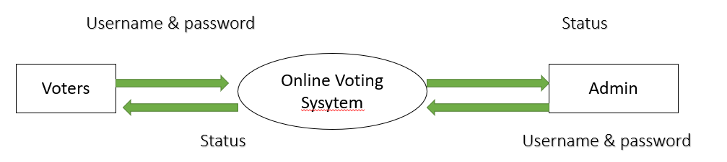

**Fig.6.1 DFD Level 0**

**6.4.2. DFD Level 1:**

In the DFD level 1, Voter and candidates are Created and the details of the voter and the candidate are stored in the database. Before that voter and the candidate must login to the website then only the list of the candidates will display in the Screen.

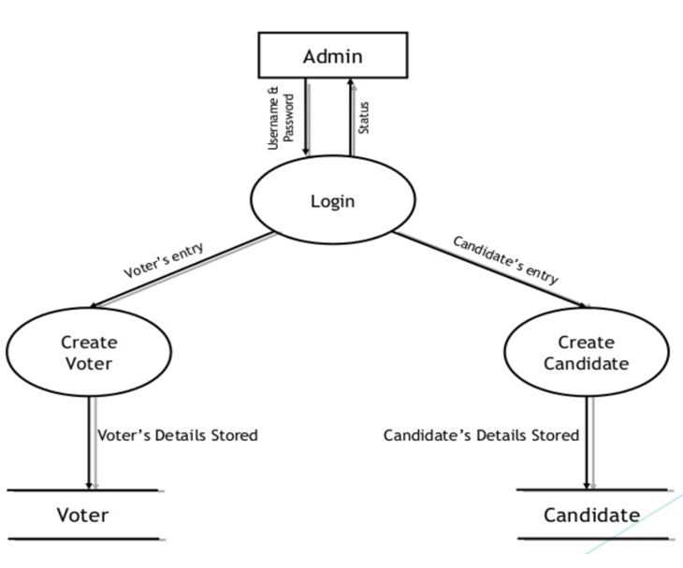

**Fig.6.2 DFD Level 1**

**6.5 ER DIAGRAM**

An entity–relationship model (ER model) describes inter-related things of interest in a specific domain of knowledge. An ER model is composed of entity types (which classify the things of interest) and specifies relationships that can exist between instances of those entity types. In software engineering an ER model is commonly formed to represent things that a business needs to remember in order to perform business processes. Consequently, the ER model becomes an abstract data model that defines a data or information structure that can be implemented in a database, typically a relational database.

Entity–relationship modeling was developed for database design by Peter Chen and published in a 1976 paper. Some ER modelers show super and subtype entities connected by generalization-specialization relationships, and an ER model can be used also in the specification of domain-specific ontology.

**6.5.1 Voting System**

The entities used are adding a voter, candidate, Admin, balance, Phone number, Name, mail id, OTP, wrong entry of OTP, resend OTP, beneficiary added , fund transferred, mini statement displayed, current balance.

The ER Diagram for all the process flow is been given as follows.

The Diagram is been given for all the processes such as the process flow is been specified.

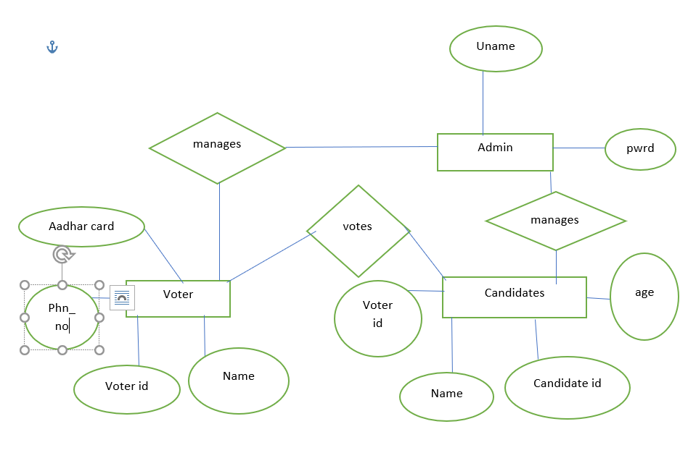

**6.3 Flow of voter and candidate registration process**

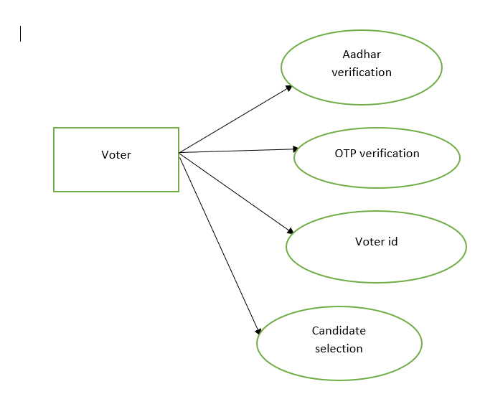

**6.4 Voter Details**

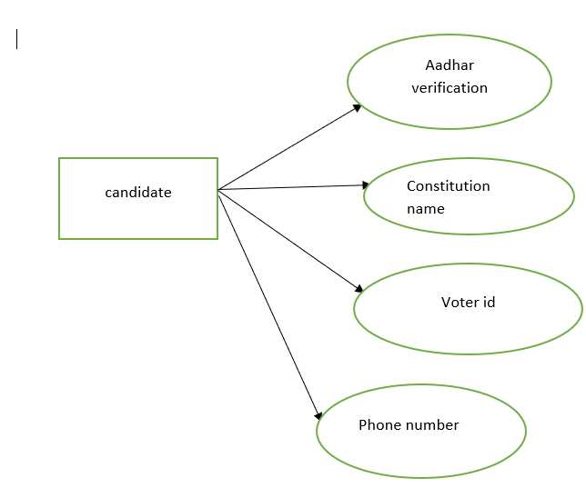

**6.5 Candidate Details**

**6.6 DATABASE DESIGN**

Database design is the process of producing a detailed data model of database. This data model contains all the needed logical and physical design choices and physical storage parameters needed to generate a design in a data definition language, which can then be used to create a database. A fully attributed data model contains detailed attributes for each entity.

The term database design can be used to describe many different parts of the design of an overall database system. Principally, and most correctly, it can be thought of as the logical design of the base data structures used to store the data. In the relational model these are the tables and views. In an object database the entities and relationships map directly to object classes and named relationships. However, the term database design could also be used to apply to the overall process of designing, not just the base data structures, but also the forms and queries used as part of the overall database application within the database management system (DBMS).

**TABLE 6.6.1 Voter and Candidate Registration Process**

|  |  |  |
| --- | --- | --- |
| **S.NO** | **FIELD NAME** | **DATATYPE** |
| 1 | Aadhar Number | Numeric |
| 2 | Voter id Number | Numeric |
| 3 | Name | Varchar |
| 4 | Phone Number | Numeric |
| 5 | Candidate id | Varchar |

**TABLE 6.6.2 Voter Details**

|  |  |  |
| --- | --- | --- |
| **S.NO** | **FIELD NAME** | **DATATYPE** |
| 1 | Name | Varchar |
| 2 | Voter id | Numeric |
| 3 | OTP Verification | Numeric |

**TABLE 6.6.2 Candidate Details**

|  |  |  |
| --- | --- | --- |
| **S.NO** | **FIELD NAME** | **DATATYPE** |
| 1 | Name | Varchar |
| 2 | Voter id | Numeric |
| 3 | OTP Verification | Numeric |
| 4 | Constitution Name | Varchar |

**6.7 INPUT DESIGN**

The input design is the link between the information system and the user. It comprises the developing specification and procedures for data preparation and those steps are necessary to put transaction data in to a usable form for processing can be achieved by inspecting the computer to read data from a written or printed document or it can occur by having people keying the data directly into the system. The design of input focuses on controlling the amount of input required, controlling the errors, avoiding delay, avoiding extra steps and keeping the process simple. The input is designed in such a way so that it provides security and ease of use with retaining the privacy. Input Design considered the following things:

* What data should be given as input?
* How the data should be arranged or coded?
* The dialog to guide the operating personnel in providing input.
* Methods for preparing input validations and steps to follow when error occur.

Input Design is the process of converting a user-oriented description of the input into a computer-based system. This design is important to avoid errors in the data input process and show the correct direction to the management for getting correct information from the computerized system.

It is achieved by creating user-friendly screens for the data entry to handle large volume of data. The goal of designing input is to make data entry easier and to be free from errors. The data entry screen is designed in such a way that all the data manipulates can be performed. It also provides record viewing facilities.

When the data is entered it will check for its validity. Data can be entered with the help of screens. Appropriate messages are provided as when needed so that the user will not be in maize of instant. Thus the objective of input design is to create an input layout that is easy to follow.

**6.8 OUTPUT DESIGN**

A quality output is one, which meets the requirements of the end user and presents the information clearly. In any system results of processing are communicated to the users and to other system through outputs. In output design it is determined how the information is to be displaced for immediate need and also the hard copy output. It is the most important and direct source information to the user. Efficient and intelligent output design improves the system’s relationship to help user decision-making.

**CHAPTER 7**

**SYSTEM TESTING**

System Testing is a level of the software testing where complete and integrated software is tested. The purpose of this test is to evaluate the system's compliance with the specified requirements. By definition of ISTQB system testing is the process of testing an integrated system to verify that it meets specified.

**7.1 TESTING METHODS**

Software Testing Type is a classification of different testing activities into categories, each having, a defined test objective, test strategy, and test deliverables. The goal of having a testing type is to validate the Application under Test for the defined Test Objective.

For instance, the goal of Accessibility testing is to validate the AUT to be accessible by disabled people. So, if your Software solution must be disabled friendly, you check it against Accessibility Test Cases.

**7.2 TYPES OF TESTING**

**7.2.1 Unit Testing**

In computer programming, unit testing is a software testing method by which individual units of source code, sets of one or more computer program modules together with associated control data, usage procedures, and operating procedures, are tested to determine whether they are fit for use.

In this voting system, every units of code has been tested and the correctness of every module is been ensured.

**7.2.2 Integration Testing**

Integration testing (sometimes called integration and testing, abbreviated I&T) is the phase in software testing in which individual software modules are combined and tested as a group. It occurs after unit testing and before validation testing. Integration testing takes as its input modules that have been unit tested, groups them in larger aggregates, applies tests defined in an integration test plan to those aggregates, and delivers as its output the integrated system ready for system testing.

In this system, the units are been tested as a whole and the testing was successful.

**7.2.3 Functional Testing**

Functional testing is a quality assurance (QA) process and a type of black-box testing that bases its test cases on the specifications of the software component under test. Functions are tested by feeding them input and examining the output, and internal program structure is rarely considered (unlike white-box testing). Functional testing usually describes what the system does. Functional testing does not imply that you are testing a function (method) of your module or class. Functional testing tests a slice of functionality of the whole system.

Functional testing has many types:

* Smoke testing
* Sanity testing
* Regression testing
* Usability testing

**7.2.4 Stress Testing**

Stress testing a Non-Functional testing technique that is performed as part of performance testing. During stress testing, the system is monitored after subjecting the system to overload to ensure that the system can sustain the stress.

Reasons can include:

* to determine breaking points or safe usage limits
* to confirm mathematical model is accurate enough in predicting breaking points or safe usage limits
* to confirm intended specifications are being met
* to determine modes of failure (how exactly a system fails)
* to test stable operation of a part or system outside standard usage

The recovery of the system from such phase (after stress) is very critical as it is highly likely to happen in production environment.

In this voting system, whole of the modules are been tested and it has the safe usage measures.

**7.2.5 Acceptance Testing**

Acceptance Testing is a level of the software testing where a system is tested for acceptability. The purpose of this test is to evaluate the system’s compliance with the business requirements and assess whether it is acceptable for delivery.

Formal testing with respect to user needs, requirements, and business processes conducted to determine whether or not a system satisfies the acceptance criteria and to enable the user, customers or other authorized entity to determine whether or not to accept the system.

In this system, the customer’s acceptance is been monitored and it is been put into usage.

**7.2.6 White Box Testing**

White Box Testing is the testing of a software solution's internal coding and infrastructure. It focuses primarily on strengthening security, the flow of inputs and outputs through the application, and improving design and usability. White box testing is also known as Clear Box testing, Open Box testing, Structural testing, Transparent Box testing, Code-Based testing, and Glass Box are testing. It is one of two parts of the "box testing" approach of software testing. Its counter-part, black box testing, involves testing from an external or end-user type perspective. On the other hand, White box testing is based on the inner workings of an application and revolves around internal testing.

The term "white box" was used because of the see-through box concept. The clear box or white box name symbolizes the ability to see through the software's outer shell (or "box") into its inner workings. Likewise, the "black box" in "black box testing" symbolizes not being able to see the inner workings of the software so that only the end-user experience can be tested.

In this voting system, all the inner functionality is been tested and it is been correctly implemented.

**7.2.7 Black Box Testing**

Black box testing is a software testing techniques in which functionality of the software under test (SUT) is tested without looking at the internal code structure, implementation details and knowledge of internal paths of the software. This type of testing is based entirely on the software requirements and specifications.

In this system, the implementation part is been checked for its correctness.

**7.2.7.1 Methods of Black Box Testing**

There are many types of Black Box Testing but following are the prominent ones -

* Functional testing - This black box testing type is related to functional requirements of a system; it is done by software testers.
* Non-functional testing - This type of black box testing is not related to testing of a specific functionality, but non-functional requirements such as performance, scalability, usability.
* Regression testing - Regression testing is done after code fixes, upgrades or any other system maintenance to check the new code has not affected the existing code.

**7.3 TESTING STRATEGY**

Test Strategy is also known as test approach defines how testing would be carried out. Test approach has two techniques:

* Proactive - An approach in which the test design process is initiated as early as possible in order to find and fix the defects before the build is created.
* Reactive - An approach in which the testing is not started until after design and coding are completed.

Test strategy calls for implementing two entirely different methodologies for testing this project. The voting system includes a fair amount of manual UI-based testing.

In this voting system, proactive approach is been used for testing. Since proactive approach is efficient it is been used in this voting system.

**CHAPTER 8**

**SYSTEM IMPLEMENTATION**

The system is been implemented as follows:

**8.1 ACCOUNT CREATION:**

It is handy to create a Voter System in the Web in which it prompts for a simple login with the Username and the password credentials, on verification of the Username, it allows the user to create an account on the Web using Java script Framework.

**8.2 WEB CREATION**

To create a Web, click on the plus symbol which is available on the framework screen. Click on the login text that navigates to the form that prompts for the Username, description of the Web, nature of visibility whether it can be public or private etc. The things that are needed can be selected by the user and finally Web is created.

**8.3 BUILDING THE VOTER SYSTEM**

The System is then made to build either by creating new skills or by selecting any of the existing skill sets available. Voter system building forms the main task in creating the web which allows creating triggers, setting the corresponding requirements and performs necessary actions. This is main motive in performing the building task.

**8.3.1 CREATING TRIGGERS**

Trigger creation forms the main part in which the intents that are created or forked can be invoked in this tab. The triggers can be made to perform the actions such as creating the corresponding action when the intent is present or not present or missing. The default will be present and this can be altered based on the condition required. The actions will be triggered only based on this condition.

**8.3.2 REQUIREMENTS**

The requirements tab allows the user to perform the relevant tasks that are been pertained based on the condition given on the trigger tab. Generally, the requirements are been specified in special cases if not required then it can be omitted.

**8.4 WEB HOSTING**

The Voter Web has been hosted with ngrok which is the public URL in order to connect the web with API that results in displaying the request and response slug. This is done using request token. The system has been connected with the slug and with the API for the accurate response.

**8.5 VOTING SYSTEM ANALTICS**

Voting system analytics is made just to analyze the performance of the system and it will have all the logs of user and the candidate. It also count the number of occurrence of the vote and whether the voting is successful or not. If the user’s vote is not found, then it displays the default vote as Nota.

**CHAPTER 9**

**CONCLUSION & FUTURE ENHANCEMENTS**

**9.1 CONCLUSION**

Thus this project Smart Voting System will be more efficient while it is been put into practice and it helps the User to easily perform the user’s action of performing various Voting tasks. It allows the user to vote in an easier way by clicking the logo of the parties. By using this web Nobody can brainwash the user to vote for another party. So, user will have no issues in using this Web Voter-System.

**9.2 FUTURE ENHANCEMENT**

This project is focused on Voting System that performs the Voting operations. The future enhancements can be done by using the voice recognition mechanism and the System can be deployed in various social channels and it can be made to implement in different languages.

**CHAPTER 10**

**APPENDIX**

**10.1 SOURCE CODE**

**INDEX.PHP**

<html>

</head>

<link rel="stylesheet" type='text/css' href="style.css">

</head>

</body>

<div class="mainwrapper">

<div id="elem">

<h1>TO CAST YOUR VOTE</h1>

<div id="pagbtns">

<button onclick="myFunction1()">Login</button>

<button onclick="myFunction()">Register</button>

</div>

</div>

<div id="signin">

<form class="box" action="index.php" method="post">

<h1 style="font-family:Arial;">Login</h1>

<input type="text" id="fullname" name="fullname" placeholder="Full name" REQUIRED><br>

<input type="text" id="voterid" name="voterid" placeholder="Voter_Id" REQUIRED><br>

<input type="password" id="password" name="passwordlogin" placeholder="Password" REQUIRED><br>

<?php if(in_array("Name or password was incorrect<br>", $error_array)) echo '<span style="color:red;";>Name or password was incorrect<br></span>'; ?>

<input type="submit" id="ent" name="ent" value="LOGIN">

<button onclick="myFunction()">SignUp</button>

</form>

</div>

<div id="signup">

<br>

<form class="box2" action="index.php" method="POST" enctype="multipart/form-data">

<span id="reg" style="color:grey;font-family:Arial";>REGISTER</span><br><br>

<input type="text" id="fullname" name="fullname" placeholder="Enter Your Full Name" value="<?php if(isset($_SESSION['fullname'])){echo $_SESSION['fullname'];} ?>" REQUIRED><br><?php if(in_array("Your full name must be between 2 and 30 character<br>", $error_array)) echo '<span style="color:red;">Your full name must be between 2 and 30 character<br></span>'; ?>

<input type="text" id="fathername" name="fathername" placeholder="Enter Your Fathers Name"><br>

<label for="date" class="btn" style="color:grey;font-family:Arial";>Your Date Of Birth</label><br>

<input type="date" id="date" name="date" style="color:grey";><br>

<input type="email" id="em" name="email" placeholder="Enter Your Email" REQUIRED><br>

<input type="text" id="mobilenumber" name="mobilenumber" placeholder="Enter Your Mobile Number"><br>

<textarea id="address" name="address" placeholder="Enter Address"></textarea><br>

<select id="district" name="district">

<option value="" disabled selected>Select Your district</option>

<option>CBE</option>

</select><br>

<select id="state" name="constitution">

<option value="" disabled selected>Select Your Constitution</option>

<option>NORTH</option>

</select><br>

<input type="text" id="boothid" name="boothid" placeholder="Enter Voting Booth ID" REQUIRED><br>

<input type="text" id="AadharID" name="aadharid" placeholder="Enter Your Aadhar ID" REQUIRED><br>

<input type="text" id="VoterID" name="voterid" placeholder="Enter Your Voter ID" REQUIRED><br>

<label for="file" class="btn" style="color:grey;font-family:Arial";>Upload Aadhar</label><br>

<input type="file" id="file" name="myfile" REQUIRED><br>

<label for="vfile" class="btn" style="color:grey;font-family:Arial";>Upload Voter</label><br>

<input type="file" id="vfile" name="myvfile" REQUIRED><br>

<input type="password" id="password" name="password" placeholder="Create Password" REQUIRED><br>

<input type="password" id="cpassword" name="cpassword" placeholder="Retype Password" REQUIRED><br>

<?php if(in_array("Your passwords do not match<br>", $error_array)) echo '<span style="color:red;">Your passwords do not match<br></span>';else if(in_array("your password must be between 5 and 30 characters<br>", $error_array)) echo '<span style="color:red;">your password must be between 5 and 30 characters<br></span>'; ?>

<input type="submit" id="submit" name="submit" value="CREATE">

<button id="bt1" onclick="myFunction1()">LOGIN</button>

</form>

</div>

</div>

<script>

function myFunction() {

document.getElementById("signup").style.display = "block";

document.getElementById("signin").style.display = "none";

document.getElementById("elem").style.display = "none";

}

function myFunction2() {

document.getElementById("signup").style.display = "block";

document.getElementById("signin").style.display = "none";

document.getElementById("elem").style.display = "none";

}

function myFunction1() {

document.getElementById("signin").style.display = "block";

document.getElementById("signup").style.display = "none";

document.getElementById("elem").style.display = "none";

}

</script>

</body>

</html>

**DEPENDENCIES.PHP**

<?php

// DIC configuration

$container = $app->getContainer();

// view renderer

$container['renderer'] = function ($c) {

$settings = $c->get('settings')['renderer'];

return new Slim\Views\PhpRenderer($settings['template_path']);

};

// monolog

$container['logger'] = function ($c) {

$settings = $c->get('settings')['logger'];

$logger = new Monolog\Logger($settings['name']);

$logger->pushProcessor(new Monolog\Processor\UidProcessor());

$logger->pushHandler(new Monolog\Handler\StreamHandler($settings['path'], $settings['level']));

return $logger;

};

$container['db'] = function ($container) {

$capsule = new \Illuminate\Database\Capsule\Manager;

$capsule->addConnection($container['settings']['db']);

$capsule->setAsGlobal();

$capsule->bootEloquent();

return $capsule;

};

**MIDDLEWARE.PHP**

<?php

// Application middleware

// e.g: $app->add(new \Slim\Csrf\Guard);

**CONFIGURATION>PHP**

<?php

ob_start();

session_start();

$con = mysqli_connect("localhost", "root" , "", "voterdb");

if(mysqli_connect_errno()){

echo "Failed to connect:" . mysqli_connect_errno();

}

?>

**LOGIN.PHP**

<?php

if(isset($_POST['ent'])){

$fullname = $_POST['fullname'];

$_SESSION['fullname'] = $fullname;

$voterid= $_POST['voterid'];

$passwordlogin = $_POST['passwordlogin'];

$check_database_query = mysqli_query($con, "SELECT * FROM votertb WHERE Full_name='$fullname' AND Voter_Id='$voterid' AND password='$passwordlogin'");

$check_login_query=mysqli_num_rows($check_database_query);

$sql1 = "SELECT fullname FROM voterresult WHERE fullname='$fullname' AND voterid='$voterid'";

$result1 = $con->query($sql1);

if ($result1->num_rows > 0) {

// output data of each row

while($row1 = $result1->fetch_assoc()) {

$ans = $row1["fullname"];

}

if($ans==$fullname){

echo '<script>alert("already voted");</script>';

session_destroy();

}

}

else{

if($check_login_query == 1){

$row = mysqli_fetch_array($check_database_query);

$voterid = $row['Voter_Id'];

$_SESSION['Voter_Id'] = $voterid;

header("Location: dashboard.php");

exit();

}

else{

array_push($error_array, "Name or password was incorrect<br>");

echo '<script>alert("Login details incorrect!!");</script>';

session_destroy();

}

}

}

**REGISTRATION.PHP**

<?php

error_reporting(0);

$fullname = "";

$fathername = "";

$d_o_b = "";

$em = "";

$mobilenumber = "";

$address ="";

$district = "";

$constitution = "";

$boothid = "";

$aadharid = "";

$aadharfile = "";

$voterid = "";

$voterfile = "";

$password = "";

$cpassword = "";

$error_array = array();

if(isset($_POST['submit'])){

$fullname = strip_tags($_POST['fullname']);

$fullname = str_replace(' ','',$fullname);

$fullname = ucfirst(strtolower($fullname));

$_SESSION['fullname'] = $fullname;

$fathername = strip_tags($_POST['fathername']);

$fathername = str_replace(' ','',$fathername);

$fathername = ucfirst(strtolower($fathername));

$d_o_b = $_POST['date'];

$em = $_POST['email'];

$mobilenumber = $_POST['mobilenumber'];

$address = $_POST['address'];

$district = $_POST['district'];

$constitution = $_POST['constitution'];

$boothid = $_POST['boothid'];

$aadharid = $_POST['aadharid'];

$voterid = $_POST['voterid'];

$password = strip_tags($_POST['password']);

$cpassword = strip_tags($_POST['cpassword']);

$name = $_FILES['myfile']['name'];

$temp_name = $_FILES['myfile']['tmp_name'];

if(isset($name) and !empty($name)){

$location = 'images/upload/';

if(move_uploaded_file($temp_name, $location.$name)){

}

}

$name1 = $_FILES['myvfile']['name'];

$temp_name1 = $_FILES['myvfile']['tmp_name'];

if(isset($name1) and !empty($name1)){

$location = 'images/upload/';

if(move_uploaded_file($temp_name1, $location.$name1)){

}

}

if(filter_var($em, FILTER_VALIDATE_EMAIL)){

$em = filter_var($em, FILTER_VALIDATE_EMAIL);

$e_check = mysqli_query($con, "SELECT email FROM votertb WHERE email ='$em'");

$num_rows = mysqli_num_rows($e_check);

if($num_rows >0){

array_push($error_array, "Email already in use<br>");

}

}

else{

array_push($error_array, "Invalid email format<br>");

}

if(strlen($fullname) > 30 || strlen($fullname) < 2){

array_push($error_array, "Your full name must be between 2 and 30 character<br>");

}

if($password != $cpassword){

array_push($error_array, "Your passwords do not match<br>");

}

if(strlen($password > 30 || strlen($password) < 5)){

array_push($error_array, "your password must be between 5 and 30 characters<br>");

}

if(empty($error_array)){

$query = mysqli_query($con, "INSERT into votertb VALUES ('', '$fullname', '$fathername', '$d_o_b', '$em', '$mobilenumber', '$address', '$district', '$constitution', '$boothid', '$aadharid', '$name', '$voterid', '$name1', '$password')");

echo '<script>alert("Registraion Successful\nKindly Login");</script>';\

header("Location:index.php");

}

else{

echo '<script>alert("Registraion failed due to incorrect details\nKindly register again");</script>';

}}

**CANDIDATE DETAILS.PHP**

<?php

require 'config.php';

if(isset($_SESSION['fullname'])){

$userLoggedIn = $_SESSION['fullname'];

$user_details_query = mysqli_query($con, "SELECT * FROM votertb WHERE Full_name='$userLoggedIn'");

$user = mysqli_fetch_array($user_details_query);

}

else{

header("Location: index.php");

}

?>

<html>

<head>

<link rel="stylesheet" type="text/css" href="dashboard_style.css">

</head>

<body>

<?php

error_reporting(0);

$f1 = $user['Full_name'];

$v1 = $user['Voter_Id'];

$party = $_POST['party'];

if(isset($_POST['vote_sub'])){

$query = mysqli_query($con, "INSERT into voterresult VALUES ('', '$f1', '$v1', '$party')");

header("Location: report.php");

}

?>

<div id="profile">

<div id="voting_panel">

<div id="voting_header">Voting Panel</div>

<div id="voting_sub">

<ul style="list-style:none;font-size:18px;">

<li>DISTRICT<?php echo " : ",$user['district']; ?></li>

<li>CONSTITUTION<?php echo " : ",$user['Constitution']; ?></li>

<li>VOTER_ID<?php echo " : ",$user['Voter_Id']; ?></li>

<li>BOOTH_ID<?php echo " : ",$user['Booth_Id']; ?></li>

</ul>

</div>

<div id="voting_main">

<form action="dashboard.php" method="Post">

<table>

<tr>

<th>S.NO</th>

<th>Party Name</th>

<th>Candidate Name</th>

<th>Vote</th>

</tr>

<tr>

<td>1.</td>

<td>BJP</td>

<td>S.Murugan</td>

<td><input type="radio" name="party" value="BJP" required></td>

</tr>

<tr>

<td>2.</td>

<td>Congress</td>

<td>M.Rajan</td>

<td><input type="radio" name="party" value="Congress"></td>

</tr>

<tr>

<td>3.</td>

<td>ADMK</td>

<td>P.Thangavel</td>

<td><input type="radio" name="party" value="ADMK"></td>

</tr>

<tr>

<td>4.</td>

<td>DMK</td>

<td>KS.Ravi</td>

<td><input type="radio" name="party" value="DMK"></td>

</tr>

</table>

<input type="submit" name="vote_sub" value="Vote your prospect" style="position:relative;left:50%;transform: translateX(-50%);top:20px;height:30px;width:200px;">

</form>

</div>

</div>

<div id="profile_sub">

<div id="Aadhar_pic"><img src="<?php echo "images/upload/", $user['Aadhar_Pic']; ?>"></div>

<div id="user_details">

<h2 style="text-align:center;position:relative;right:60px;">Voter Profile</h2>

<table style="color:white;font-size:24px;margin:0px auto;text-align:left;">

<tr><td>Name</td> <td><?php echo ": ",$user['Full_name']; ?></td></tr>

<tr><td>Father's Name</td> <td><?php echo ": ",$user['Father_name']; ?></td></tr>

<tr><td>D.O.B</td> <td><?php echo ": ",$user['D.O.B']; ?></td></tr>

<tr><td>Email</td> <td><?php echo ": ",$user['Email']; ?></td></tr>

<tr><td>Mobile Number</td> <td><?php echo ": ",$user['Mobile_number']; ?></td></tr>

<tr><td>Address</td> <td><?php echo ": ",$user['address']; ?></td></tr>

<tr><td>District</td> <td><?php echo ": ",$user['district']; ?></td></tr>

<tr><td>Constitution</td> <td><?php echo ": ",$user['Constitution']; ?></td></tr>

<tr><td>Booth_Id</td> <td><?php echo ": ",$user['Booth_Id']; ?></td></tr>

<tr><td>Aadhar_Id</td> <td><?php echo ": ",$user['Aadhar_Id']; ?></td></tr>

<tr><td>Voter_Id</td> <td><?php echo ": ",$user['Voter_Id']; ?></td></tr>

</table>

<button style="position:relative;left:40%;top:30px;transform: translateX(-50%);" onclick="votepan()">Vote</button>

</div>

<div id="voter_pic"><img src="<?php echo "images/upload/", $user['Voter_Pic']; ?>"></div>

</div>

</div>

<div id="confirm_page">

<h1>Confirmation</h1>

<?php

$cons = $user['Constitution'];

echo "Name: ", $user['Full_name'], "<br>";

echo "Voter Registration ID : ", $user['district'], substr($cons,0,2), $user['Booth_Id'], "000", $user['Id'];

echo "<br>", "Your Aadhar ID : ", $user['Aadhar_Id'];

echo "<br>", "Your Voter ID : ", $user['Voter_Id'], "<br>";

?>

<button onclick="confirm()">Confirm Voter</button><br><br>

<textarea placeholder="Reason for cancel"></textarea><br>

<button a href="logout.php" style="text-decoration:none;color:black;">Cancel Voter</button>

</div>

<script>

function confirm(){

document.getElementById("confirm_page").style.display = "none";

document.getElementById("profile_sub").style.display = "block";

document.getElementById("voting_panel").style.display = "none";

document.getElementById("profile").style.display = "block";

}

function votepan(){

document.getElementById("profile_sub").style.display = "none";

document.getElementById("voting_panel").style.display = "block";

document.getElementById("confirm_page").style.display = "none";

document.getElementById("profile").style.display = "block";

}

</script>

</body>

</html>

**DASHBOARD STYLE.CSS**

body{

margin:0px auto;

padding:0px auto;

background: #1D2B64; /* fallback for old browsers */

background: -webkit-linear-gradient(to right, #F8CDDA, #1D2B64); /* Chrome 10-25, Safari 5.1-6 */

background: linear-gradient(to right, #F8CDDA, #1D2B64); /* W3C, IE 10+/ Edge, Firefox 16+, Chrome 26+, Opera 12+, Safari 7+ */

}

#confirm_page{

background-color:white;

height:fit-content;

width:fit-content;

text-align:center;

margin:0px auto;

padding:50px;

position: relative;

top: 50%;

transform: translateY(-50%);

font-family:Arial;

display:block;

}

#profile{

height:100%;

width:100%;

background-color:#121212;

display:none;

}

#profile_sub{

height:100%;

width:100%;

background-color:#141517;

margin:0px auto;

position: relative;

top: 50%;

transform: translateY(-50%);

display:none;

background: #314755; /* fallback for old browsers */

background: -webkit-linear-gradient(to right, #26a0da, #314755); /* Chrome 10-25, Safari 5.1-6 */

background: linear-gradient(to right, #26a0da, #314755); /* W3C, IE 10+/ Edge, Firefox 16+, Chrome 26+, Opera 12+, Safari 7+ */

}

#Aadhar_pic{

height:31%;

width:22%;

background-color:grey;

float:left;

}

#user_details{

height:100%;

width:56%;

background:transparent;

float:left;

text-align:left;

font-family:Calibri;

font-size:28px;

color:white;

}

#voter_pic{

height:50%;

width:22%;

background:grey;

float:left;

}

#Aadhar_pic img{

width:100%;

height:100%;

}

#voter_pic img{

width:100%;

height:100%;

}

#voting_panel{

height:100%;

width:100%;

margin:0px auto;

position: relative;

top: 50%;

transform: translateY(-50%);

display:none;

background: #41295a; /* fallback for old browsers */

background: -webkit-linear-gradient(to right, #2F0743, #41295a); /* Chrome 10-25, Safari 5.1-6 */

background: linear-gradient(to right, #2F0743, #41295a); /* W3C, IE 10+/ Edge, Firefox 16+, Chrome 26+, Opera 12+, Safari 7+ */

}

#voting_header{

height:10%;

width:100%;

float:left;

color:white;

font-size:34px;

font-family:Verdana;

text-align:center;

}

#voting_sub{

height:20%;

width:100%;

background-color:transparent;

font-family:Arial;

color:white;

float:left;

}

#voting_main{

height:85%;

width:100%;

float:left;

}

table {

border-collapse: collapse;

width:100%;

height:70%;

text-align:center;

color:white;

font-family:Arial;

}

table, th, td {

border: 1px solid black;

}

table input[type="radio"]{

height:20px;

width:20px;

}

**STYLE.CSS**

ody{

margin:0px auto;

padding: 0px auto;

background-color:black;

overflow:hidden;

}

.mainwrapper{

height:100%;

width:100%;

background-image: linear-gradient(-225deg, #2CD8D5 0%, #6B8DD6 48%, #8E37D7 100%);

}

#elem{

margin: 0;

color:white;

font-family:calibri;

font-weight:bold;

position: absolute;

top: 50%;

left: 50%;

margin-right: -50%;

transform: translate(-50%, -50%);

font-size:25px;

}

#pagbtns{

margin-left:12px;

position:relative;

bottom:22px;

}

button{

background-color: #FE2E2E;

color: white;

margin: 0px 20px 0px 0px;

border: none;

cursor: pointer;

width: 190px;

padding:13px;

border-radius:5px;

}

#bt1{

background-color: #1569C7;

color: white;

border: none;

cursor: pointer;

width: 120px;

height:40px;

padding:13px;

border-radius:5px;

margin-left:5px;

font-weight:bolder;

}

button:hover {

opacity: 0.8;

}

input[type="submit"]:hover{

opacity:0.8;

}

#signup{

width:500px;

height:95%;

background-color:white;

position:absolute;

top:50%;

left:50%;

margin-right: -50%;

transform: translate(-50%, -50%);

text-align:center;

border-radius:35px;

display:none;

}

textarea{

resize:none;

}

.box2 input[type = "text"],.box2 input[type = "password"],.box2 input[type = "email"],.box2 input[type = "date"],.box2 textarea,.box2 select{

border:none;

background-image:none;

background: transparent;

-webkit-box-shadow: none;

-moz-box-shadow: none;

box-shadow: none;

outline:none;

border: 2px solid #3498db;

width:300px;

height:31px;

font-size:20px;

text-align:center;

font-family:calibri;

padding:0px auto;

border-radius:5px;

transition:0.3s;

margin-bottom:3px;

box-shadow: 0 2px 6px 0 rgba(0, 0, 0, 0.1), 0 4px 18px 0 rgba(0, 0, 0, 0.12);

}

.box2 textarea{

height:60px

}

.box2 input:focus,.box2 select:focus{

width: 380px;

border-color: #2ecc71;

}

select{

color:grey;

}

#submit{

border:none;

width:120px;

height:40px;

background-color:#1569C7;

color:white;

font-weight:bolder;

border-radius:5px;

cursor:pointer;

margin-top:5px;

margin-bottom:5px;

}

#signin{

height:100%;

width:100%;

background-color:transparent;

display:none;

}

.box{

width: 230px;

padding: 40px;

position: relative;

top: 50%;

left: 50%;

transform: translate(-50%,-50%);

background: rgba(255,255,255,1);

text-align: center;

color:black;

border-radius:30px;

}

.box:hover{

box-shadow: 0 4px 8px 0 rgba(0, 0, 0, 0.2), 0 6px 20px 0 rgba(0, 0, 0, 0.19);

padding:41px;

}

#reg{

color: black;

text-transform: uppercase;

font-weight: 600;

font-family:calibri;

font-weight:bold;

font-size:30px;

}

.box input[type = "text"],.box input[type = "password"]{

border:0;

background: none;

display: block;

margin:0px auto;

text-align: center;

border: 2px solid #3498db;

padding: 12px 10px;

width: 200px;

outline: none;

color: black;

border-radius: 24px;

transition: 0.25s;

}

.box input[type = "text"]:focus,.box input[type = "password"]:focus{

width: 235px;

border-color: #2ecc71;

color:black;

}

.box input[type = "submit"]{

border:0;

background: none;

display: block;

text-align: center;

border: 2px solid #2ecc71;

padding: 14px 40px;

outline: none;

color: black;

margin:0px auto;

border-radius: 24px;

transition: 0.25s;

cursor: pointer;

width:fit-content;

}

#signin button{

border:0;

background: none;

display: block;

text-align: center;

border: 1px solid #2ecc71;

padding: 5px 22px;

outline: none;

color: black;

margin:0px auto;

border-radius: 10px;

transition: 0.25s;

cursor: pointer;

width:fit-content;

margin-top:15px;

}

#signin button:hover{

background: #2ecc71;

}

.box input[type = "submit"]:hover{

background: #2ecc71;

}

**REPORT.PHP**

<?php

require 'config.php';

if(isset($_SESSION['fullname'])){

$userLoggedIn = $_SESSION['fullname'];

$user_details_query = mysqli_query($con, "SELECT * FROM votertb WHERE Full_name='$userLoggedIn'");

$user = mysqli_fetch_array($user_details_query);

$userLoggedIn1 = $_SESSION['fullname'];

$user_details_query1 = mysqli_query($con, "SELECT * FROM voterresult WHERE fullname='$userLoggedIn1'");

$user1 = mysqli_fetch_array($user_details_query1);

}

?>

<html>

<head>

<style>

body{

margin:0px auto;

padding:0px auto;

background: #ff00cc; /* fallback for old browsers */

background: -webkit-linear-gradient(to right, #333399, #ff00cc); /* Chrome 10-25, Safari 5.1-6 */

background: linear-gradient(to right, #333399, #ff00cc); /* W3C, IE 10+/ Edge, Firefox 16+, Chrome 26+, Opera 12+, Safari 7+ */

}

#report{

width:440px;

height:440px;

background-color:transparent;

margin:0px auto;

position:absolute;

top:50%;

transform: translateY(-50%);

bottom:0;

right:0;

left:0;

text-align:center;

font-size:26px;

color:white;

font-family:verdana;

}

button{

width:80px;

height:30px;

}

button a{

text-decoration:none;

color:black;

}

</style>

</head>

<body>

<div id="report">

<ul style="list-style:none;">

<li>DISTRICT<?php echo " : ",$user['district']; ?></li>

<li>CONSTITUTION<?php echo " : ",$user['Constitution']; ?></li>

<li>VOTER_ID<?php echo " : ",$user['Voter_Id']; ?></li>

<li>BOOTH_ID<?php echo " : ",$user['Booth_Id']; ?></li><br>

<li>You Voted For : <?php echo $user1['voted_for'];?></li><br><br>

Please Click the Button:

<li><button><a href="logout.php">close</a></button></li>

</ul>

</div>

</body>

</html>

**RESULTS.PHP**

<?php

$f1 = $user['Full_name'];

$v1 = $user['Voter_Id'];

$party = $_POST['party'];

if(isset($_POST['vote_sub'])){

$query = mysqli_query($con, "INSERT into voteresult VALUES ('', '$f1', 'v1', '$party')");

header("Location:report.php");

}

?>

**10.2 SCREEN SHOTS**

**10.2.1 HOME PAGE**

Login and Registration dialogue box are displayed in home page

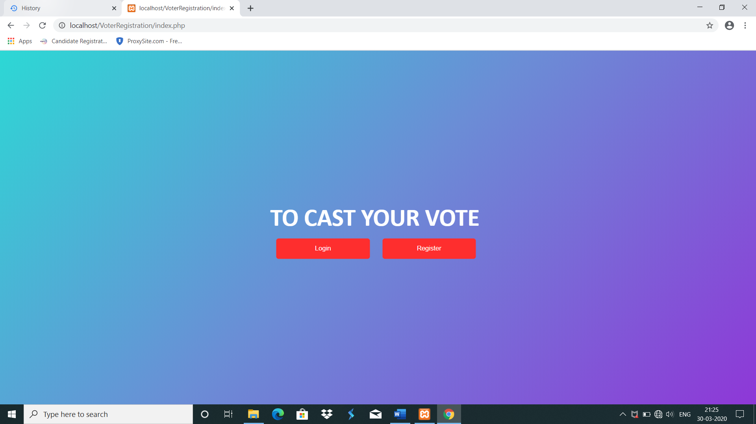

**10.2.2 LOGIN PAGE**

If a voter already have an account, they can easily login using login dialogue box. They should enter the username, Voter id number and password

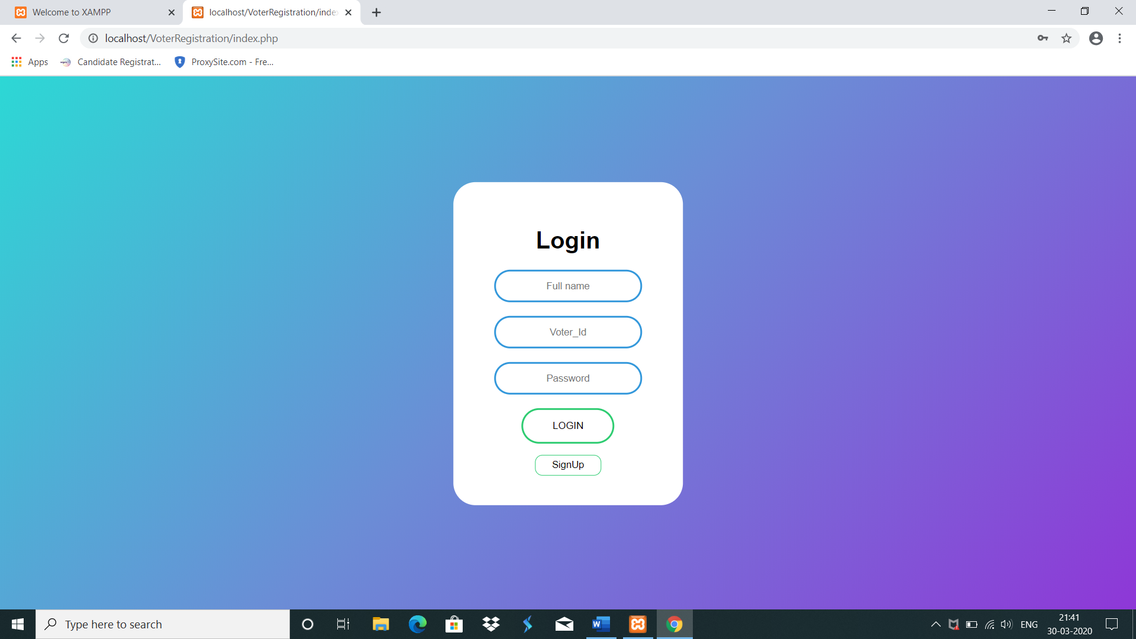

**10.2.3 REGISTRATION PAGE**

If a voter do not have an account, they must create account by registering their details

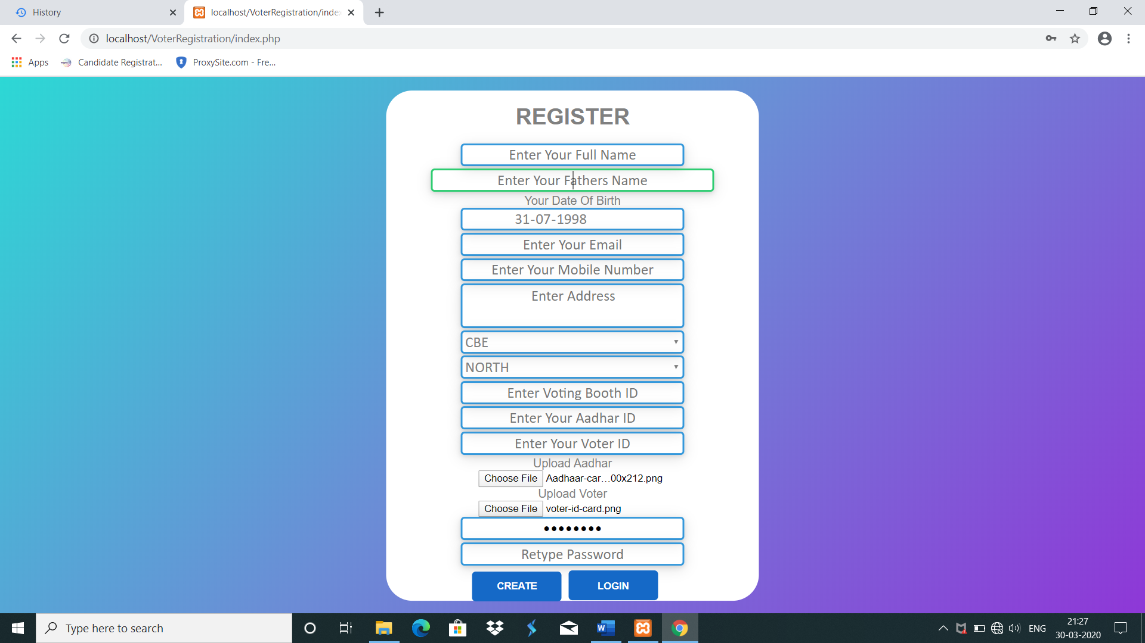

**10.2.4 VOTING PANEL**

In this page, candidates lists are displayed for the voters to vote someone

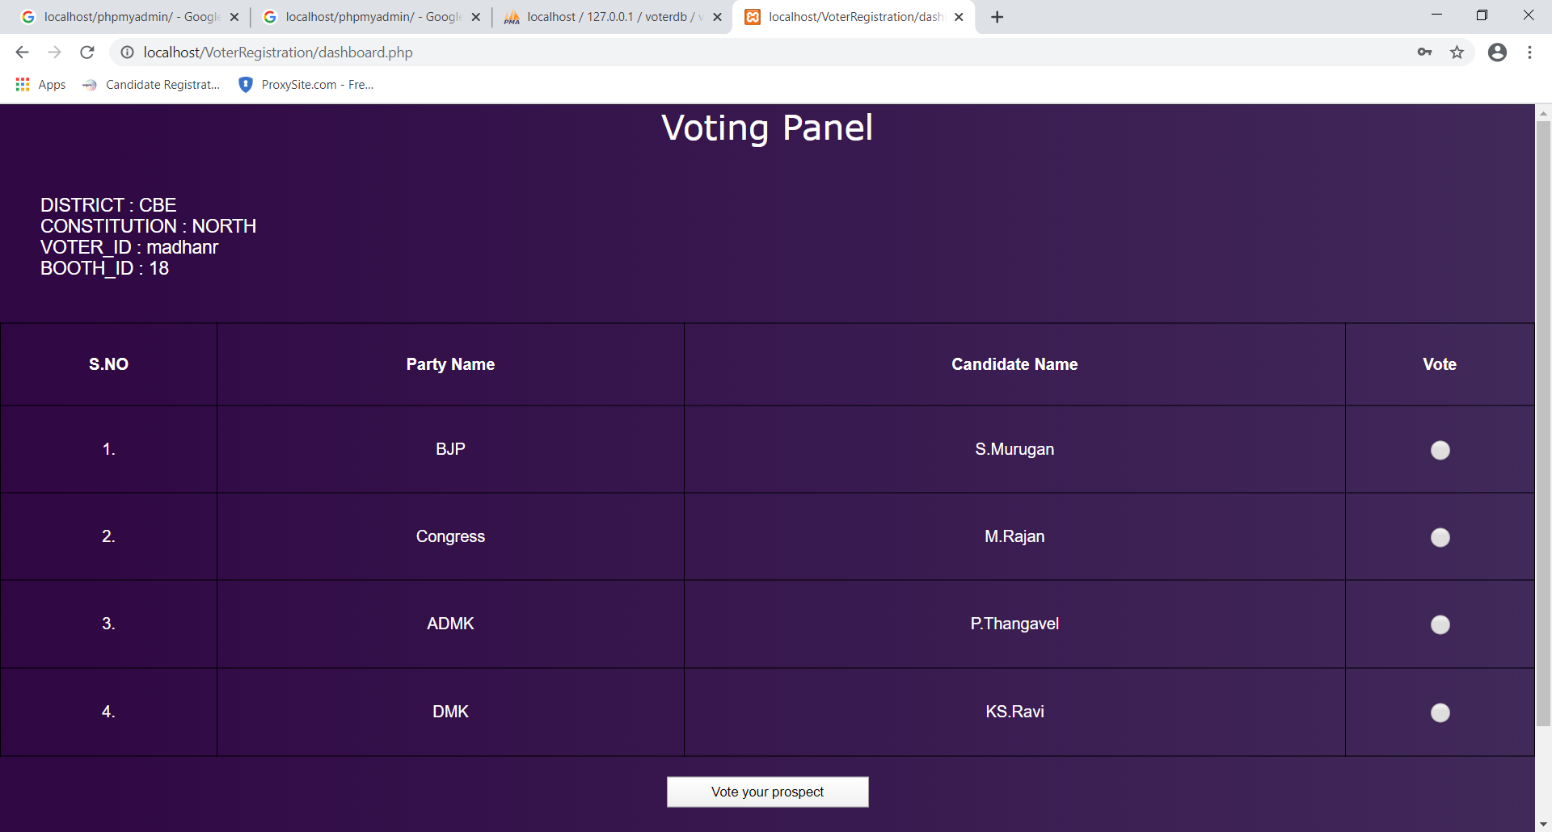

**10.2.5 VOTER PROFILE**

After registration process the voter can view his profile to ensure that all the details are correct or not.

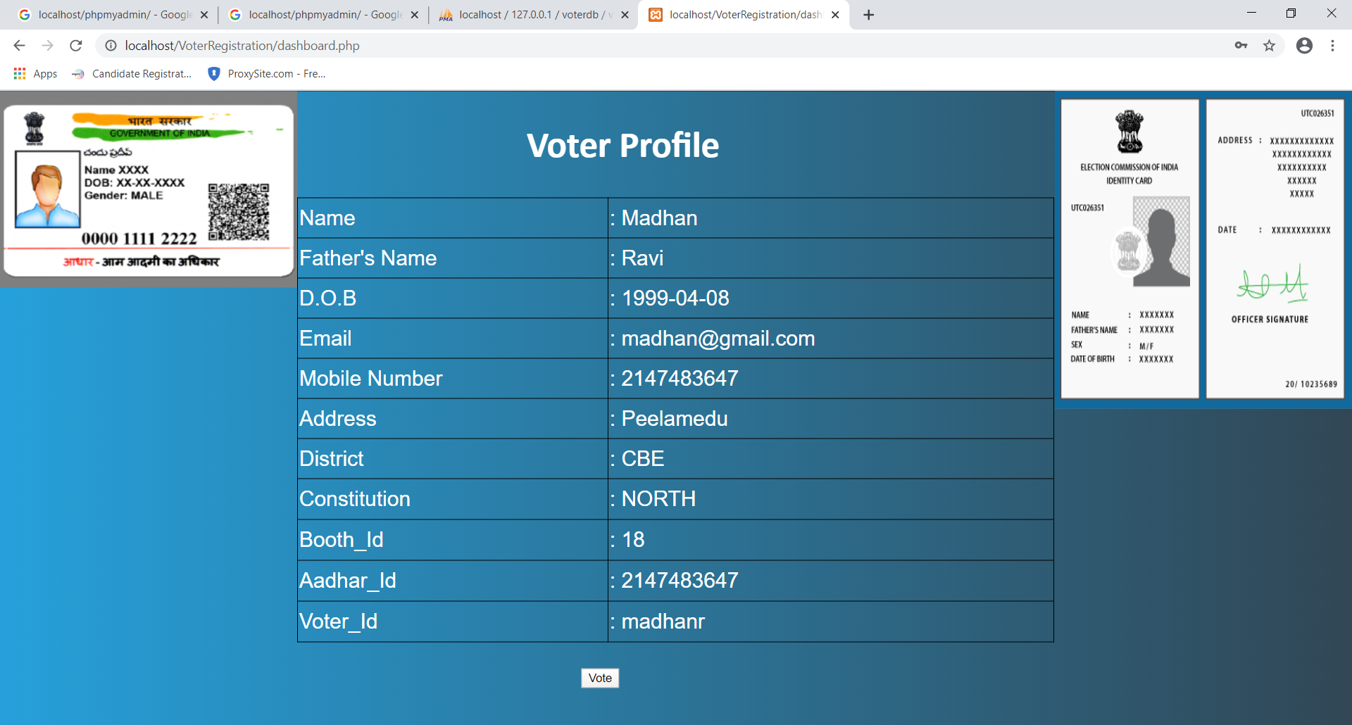

**10.2.6 VOTED DETAILS**

After voting, the voter’s district, constitution, Name, booth od and the party name to which party he voted all those things will be displayed.

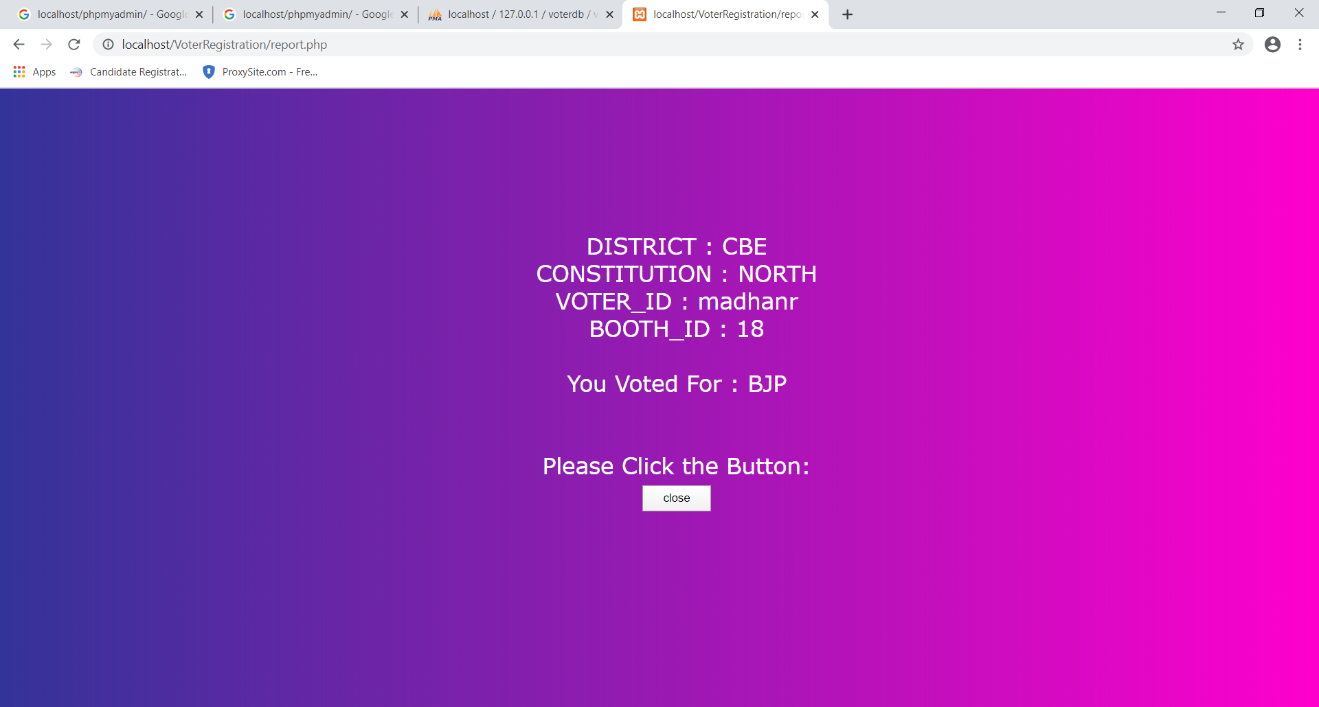

**10.2.7 VOTING CONFIRMATION**

Once voting is done, voter will receive a confirmation page.

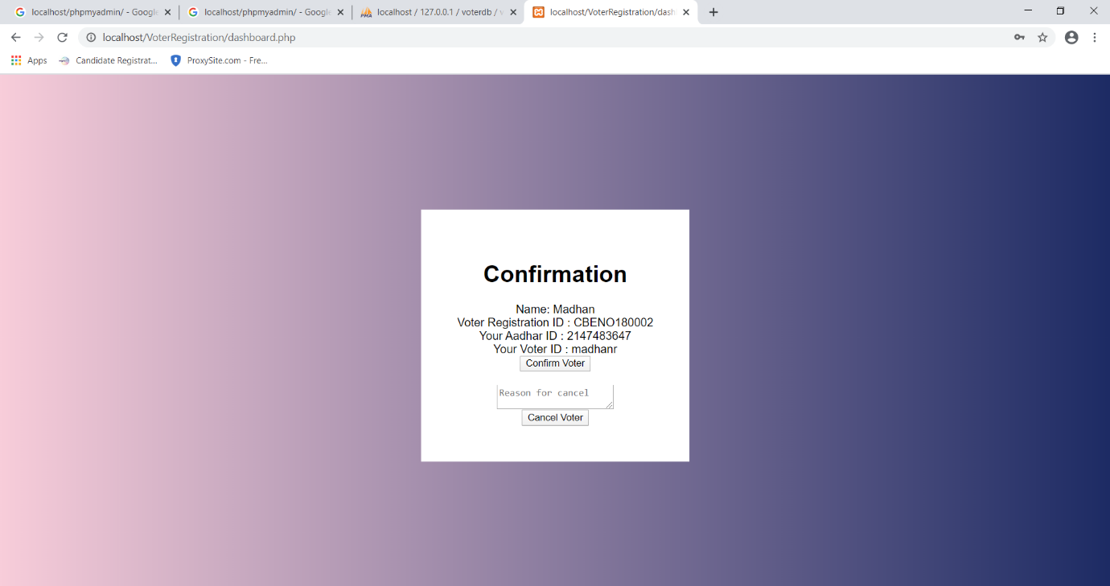

**CHAPTER 11**

**REFERENCES**

1. Google – <https://www.researchgate.net/publication/271550721_Online_voting_system_for_India_based_on_AADHAAR_ID>
2. Wikipedia - <https://en.wikipedia.org/wiki/Electronic_voting_in_India>
3. Web Page creation –https://[www.createawebsite.com](http://www.createawebsite.com)/
4. Voting System Magazine – <https://onlinevotingsystemmagazine.com/>
5. ngrok tutorial -<https://ngrok.com/>
6. Database connectivity- <http://localhost/phpmyadmin/>
7. Smart Voting System- <http://nevonprojects.com/Smartvotingsystem/>
8. Video tutorial – <https://youtu.be/JBciLCpqLcQ>
9. Voting System Tutorial – <https://phppoint.com/projects/online-voting-system-project-file>
10. IEEE Papers – [www.ieeexplore.ieee.org/document/676265](http://www.ieeexplore.ieee.org/document/676265)
11. Online_Books-https://www.researchgate.net/publications/319176839_Design_and_Implementation_of_Electronic_Voting_System